 | ASEAN TELSOM-ATRC Leaders’ Retreat  15-17 September, 2015 – Ninh Binh, Viet Nam | 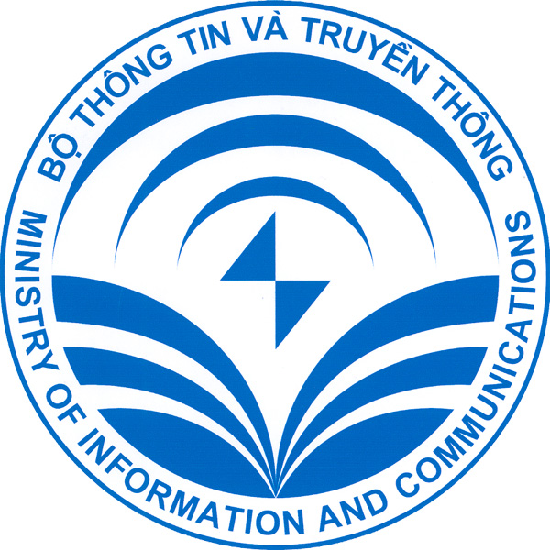

REGISTRATION FORM
PERSONAL INFORMATION
Name as in passport |  | (Mr./Ms./Mrs/Dr.)
Present Post (Title)
Organization
Business Address
Phone/Mobile No.: |  |  |  |  | Fax No.: |  |  |  |  |  | Email:
 | Head of Delegation |  |  |  |  | Accompanying Official |  |  |  |  |  | Others
PASSPORT DETAILS
Passport No.
Date of Issue
Expiry Date
Nationality
FLIGHT INFORMATION
Arrival Date: |  |  |  |  |  |  |  |  | Departure Date:
Arrival Time: |  |  |  |  |  |  |  |  | Departure Time:
Flight No.: |  |  |  |  |  |  |  |  | Flight No.:
HOTEL RESERVATION
EMERALDA RESORT – NINH BINH

□ Superior Room □ Deluxe Room
Single/Double/Twin US$ 89 Single/Double/Twin US$ 157

Check In date: |  |  |  |  |  |  | Check Out date:
Please complete the following to confirm your room reservation:
All reservations require credit card guarantee due at time of booking. The credit card information is there to verify your booking. The Credit card will not be charged unless there is no show, cancellation or early check out.
Credit Card No.
Name on the Card
Expiry Date
Type of Credit Card
Cancellation Policy:
- Cancellation/Amendment on and after 8 September 2015 will be charged at one night room charge
- No Show or Stay shortening on Arrival date is subject to 100% of total stay room charge

If making your own accommodation arrangements, please indicate your contact details:
Address
Phone No.
OTHERS:
- Accompanied by spouse:  Yes  No
- Vegetarian Diet:  Yes  No
- Halal Diet:  Yes  No
ACKNOWLEDGEMENT
Date: |  |  |  |  |  |  |  | Signature
Please email and/or fax the completed Registration Form by 1 September 2015 to:

Ms. Doan Thanh Huong
Tel: +84 4 3 772 6655 (Ext: 24)
Fax: +84 4 3 772 7216
E-mail: thanhhuong@v-lead.com.vn

And copy to:

Mr. Dao Ngoc Tuyen
Tel: + 84 4 3 8229377
Fax: + 84 4 3 8226590
E-mail: dntuyen@mic.gov.vn

SEE YOU IN NINH BINH!

